

Machine Learning Lab (CSUP521) Mini-Project Report
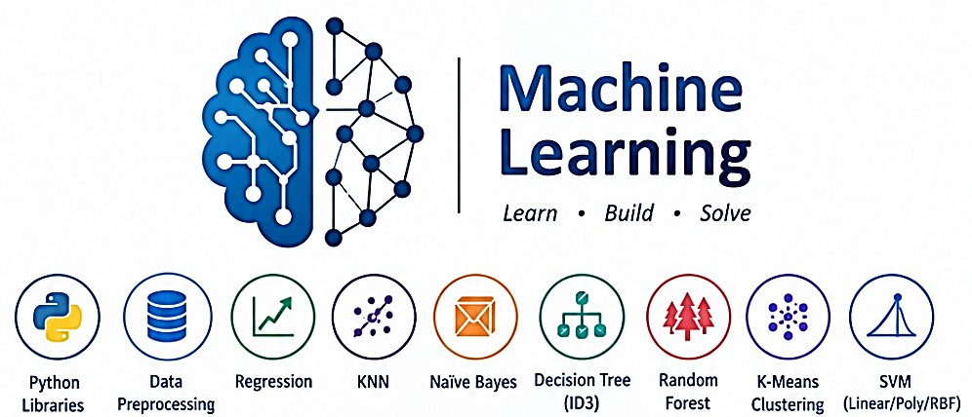

Student Name : Shabd Nothalia
Roll Number : 24ESKCS706

Semester and Section
: 5th Sem CSE-E (G1)

Project Set No. : Set-06
Project Title : Loan Approval Prediction and Applicant
Segmentation

Submission Date
: 28th Oct, 2026

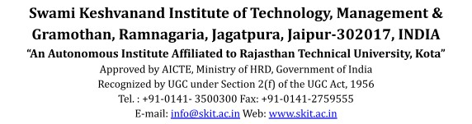
Submitted To Dr. Loveleen Kumar, Associate Professor, CSE Department,
SKIT, Jaipur

TABLE OF CONTENTS
- ABSTRACT 2
- INTRODUCTION 2
- PROBLEM STATEMENT AND OBJECTIVES 2
  - Problem statement 2
  - Objectives 2
- DATASET DESCRIPTION 3
- EXPLORATORY DATA ANALYSIS 4
- DATA PREPROCESSING AND VALIDATION STRATEGY 4
- REGRESSION ANALYSIS 4
- CLASSIFICATION: KNN AND NAIVE BAYES 5
- SVM KERNEL COMPARISON 6
- DECISION TREE AND RANDOM FOREST 7
  - Entropy-based ID3-style decision tree 7
  - Random Forest tree-count comparison 7
- K-MEANS CLUSTERING 8
- OVERALL MODEL COMPARISON 10
- FAIRNESS, PRIVACY AND CLASS IMBALANCE 11
- DISCUSSION, LIMITATIONS AND CONCLUSION 12
  - Limitations 12
  - Conclusion 12
- REFERENCES 12

ABSTRACT
This project studies a public loan-approval dataset of 614 applicant records with 13 columns (identifier, demographics, income, loan amount, credit history, property area and the historical approval outcome). The work is an educational exercise and is not intended for real lending decisions. The workflow inspects data quality and class balance, imputes missing values, encodes categorical variables and scales numerical variables inside scikit-learn pipelines so that every transformation is fitted on training data only. Linear Regression estimates the loan amount (MAE 36.61, RMSE 57.91, R2 0.090). KNN, Gaussian Naive Bayes, three SVM kernels, an entropy-based decision tree and Random Forests with 1 to 1000 trees are then compared on a stratified 80/20 split. KNN (k = 5) achieved the highest test accuracy (86.99%) and F1-score (0.913), followed by linear and RBF SVM (85.37%); the decision tree was weakest (74.80%), and Random Forest accuracy rose from 65.85% (1 tree) to 82.93% (500 trees). K-Means on scaled applicant income, co-applicant income and loan amount (k = 2, 3, 4) produces purely descriptive financial segments. All models predict the majority class (approved) far better than the minority class, and fairness, privacy and class-imbalance concerns are discussed explicitly.

INTRODUCTION
Lenders assess applications using income, credit history, loan size and other attributes. Machine learning can describe patterns in historical decisions, but historical decisions reflect the policies, constraints and possible biases of the people who made them. A model that reproduces them is therefore a description of the past, not evidence that a future applicant deserves or does not deserve credit.
This report covers three families of techniques on one dataset: regression (predicting a continuous field), classification (predicting the historical approval label) and clustering (grouping applicants by financial characteristics without using the label). Clusters are described by their numbers only, with no creditworthiness or moral labels attached.

PROBLEM STATEMENT AND OBJECTIVES

Problem statement
A lending organisation wants to study applicant data, classify historical loan approval outcomes, and group applicants by financial characteristics. The model is an educational exercise and must not be used for actual lending decisions.

Objectives
    - Load and inspect the data: target balance, missing values, categorical and numerical features.
    - Impute, encode and scale features while avoiding data leakage (transformations fitted on training data only).
    - Use Linear Regression to predict LoanAmount; report MAE, RMSE and R2 and plot actual versus predicted values.
    - Train KNN and Gaussian Naive Bayes for the approval label and show correct and incorrect predictions.
    - Compare SVM with Linear, Polynomial and RBF kernels.
    - Train an entropy-based ID3-style decision tree and Random Forests, varying the number of trees.
    - Apply K-Means (k = 2, 3, 4) to scaled financial attributes and describe the clusters neutrally.
    - Discuss fairness, privacy, class imbalance and why the result must not be an automatic approval system.

DATASET DESCRIPTION
Dataset: public Loan Prediction (loan-approval) dataset, supplied as datasets/data.csv in the project folder. It contains historical applications from a housing-loan setting with an approval outcome. Source link: https://www.kaggle.com/datasets/krishnaraj30/finance-loan-approval-prediction-data?select=train.csv

Property | Observed value
Observations | 614
Columns | 13 (11 input features after dropping Loan_ID and Loan_Status)
Exact duplicate rows | 0
Duplicate Loan_ID values | 0 (614 unique IDs)
Columns with missing values | 7 (Gender, Married, Dependents, Self_Employed, LoanAmount, Loan_Amount_Term, Credit_History)
Target | Loan_Status: Y = 422 (68.73%), N = 192 (31.27%)
Main evaluation split | Stratified 80/20; random_state = 42

Column | Type | Description / values
Loan_ID | Identifier | Unique ID; dropped before modelling
Gender | Categorical | Male 489, Female 112, missing 13
Married | Categorical | Yes 398, No 213, missing 3
Dependents | Categorical | 0: 345, 1: 102, 2: 101, 3+: 51, missing 15
Education | Categorical | Graduate 480, Not Graduate 134
Self_Employed | Categorical | No 500, Yes 82, missing 32
ApplicantIncome | Numerical | Mean 5403.46, median 3812.5, max 81000
CoapplicantIncome | Numerical | Mean 1621.25, median 1188.5, max 41667
LoanAmount | Numerical | Mean 146.41, median 128, range 9 to 700; 22 missing
Loan_Amount_Term | Numerical | Mean 342, 10 distinct values; 14 missing
Credit_History | Numerical (0/1) | Mean 0.842; 50 missing
Property_Area | Categorical | Semiurban 233, Urban 202, Rural 179
Loan_Status | Target | Y / N
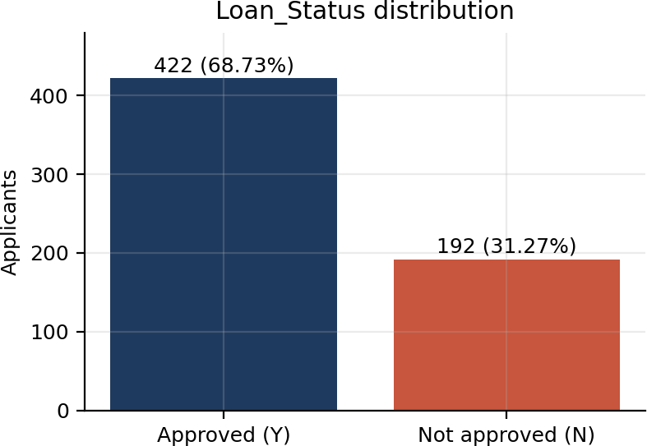
Figure 4.1. Distribution of the historical approval label.

Limitations of the dataset. It is small (614 rows), historical, from a single lender, and contains sensitive attributes (gender, marital status, dependents, property area). The meaning of the LoanAmount unit is as recorded in the source and is not converted here. The approval label reflects past decisions, not a ground

truth of repayment ability.

EXPLORATORY DATA ANALYSIS
The target is moderately imbalanced: 68.73% of applicants were approved. A model that always predicts “Y” would therefore score about 69% accuracy, so precision, recall, F1-score and per-class recall are reported alongside accuracy.
Missing values are most frequent in Credit_History (50 rows, 8.1%), Self_Employed (32), LoanAmount (22), Dependents (15), Loan_Amount_Term (14), Gender (13) and Married (3). Income variables are strongly right-skewed (ApplicantIncome mean 5403 against median 3812; maximum 81000), which later influences K-Means. Credit_History is binary and has a median of 1, i.e. most applicants have a recorded positive history.
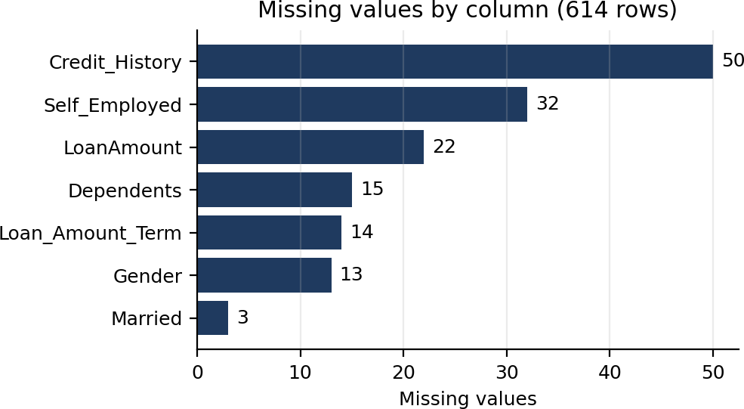

Figure 5.1. Number of missing values per column.

DATA PREPROCESSING AND VALIDATION STRATEGY
A copy of the data is kept (data_clean) and leading/trailing whitespace is stripped from column names and categorical values. Dependents is treated as categorical because it contains the label “3+”. Loan_ID and the target are removed from the feature matrix.
Two modelling tasks are defined: classification predicts Loan_Status from 11 features (614 rows) and regression predicts LoanAmount from 10 features, using only the 592 rows where LoanAmount is known (rows with a missing target are excluded for that experiment). Both datasets are split 80/20 with random_state = 42; the classification split is stratified (training 491 rows, 337 Y / 154 N; testing 123 rows, 85 Y / 38 N).

Step | Numerical features | Categorical features
Imputation | SimpleImputer (median) | SimpleImputer (most frequent)
Transformation | StandardScaler | OneHotEncoder (handle_unknown = ignore)
Both preprocessors are wrapped in a ColumnTransformer inside a scikit-learn Pipeline with the model, and each classifier receives its own clone. Because imputation, encoding and scaling are fitted only when the pipeline is fitted on the training set, test-set statistics never leak into training. The K-Means preprocessing (median imputation and scaling of three financial columns) is fitted on all rows, which is acceptable for an unsupervised, descriptive analysis that uses no labels and makes no predictions on new data.

REGRESSION ANALYSIS
Linear Regression was trained to predict LoanAmount from applicant attributes (473 training and 119 testing rows). Performance on the held-out rows is:

Metric | Value
MAE | 36.6080
RMSE | 57.9066
R2 | 0.0904
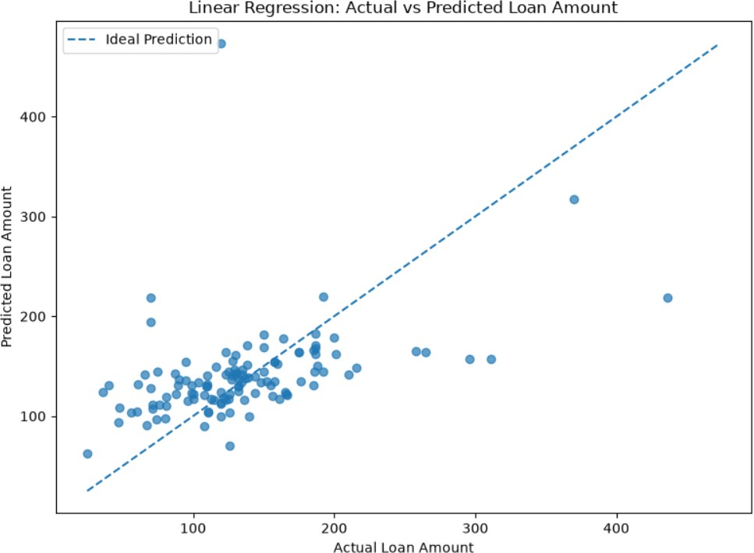
Figure 7.1. Linear Regression: actual versus predicted loan amount (dashed line = ideal prediction).
With an R2 of about 0.09, the model explains only roughly 9% of the variance in loan amount; the typical error (MAE about 37) is large relative to the median loan amount of 128. Predictions cluster between roughly 90 and 200 and do not follow the ideal line for large loans: the three or four largest actual amounts (about 260 to 435) are strongly under-predicted, and one test point near an actual value of 120 is over-predicted at about 475. The result indicates that the available attributes are weak linear predictors of loan size, and that extreme values and skewed incomes limit a simple linear model. Log-transforming income and loan amount, or using non-linear models, would be sensible improvements.

CLASSIFICATION: KNN AND NAIVE BAYES
KNN (k = 5) classifies an applicant by majority vote among the five nearest scaled and encoded applicants. Gaussian Naive Bayes models class probabilities assuming conditionally independent features and Gaussian distributions on the encoded inputs.

Model | Accuracy | Precision (Y) | Recall (Y) | F1 (Y) | Recall (N) | Macro F1
KNN (k=5) | 0.8699 | 0.8485 | 0.9882 | 0.9130 | 0.61 | 0.83
Gaussian Naive Bayes | 0.8455 | 0.8367 | 0.9647 | 0.8962 | 0.58 | 0.80
Sample predictions (KNN). Correct examples (test-set row index shown):

Idx | Gender | Married | De p | Applicant inc. | Co-app. inc. | Loan | Credit | Area | Act. | Pred.
150 | Male | No | 0 | 6277 | 0 | 118 | 0.0 | Rural | N | N
559 | Female | Yes | 0 | 4180 | 2306 | 182 | 1.0 | Semiurban | Y | Y
598 | Male | Yes | 0 | 9963 | 0 | 180 | 1.0 | Rural | Y | Y
235 | Male | Yes | 1 | 5500 | 1260 | 170 | 1.0 | Rural | Y | Y
145 | Female | Yes | 0 | 2330 | 4486 | 100 | 1.0 | Semiurban | Y | Y

Incorrect examples (KNN):

Idx | Gender | Married | De p | Applicant inc. | Co-app. inc. | Loan | Credit | Area | Act. | Pred.
191 | Male | No | 0 | 12000 | 0 | 164 | 1.0 | Semiurban | N | Y
326 | Male | No | 0 | 4917 | 0 | 130 | 0.0 | Rural | Y | N
268 | Female | No | 0 | 3418 | 0 | 135 | 1.0 | Rural | N | Y
479 | Male | Yes | 2 | 2947 | 1603 | 123 | 1.0 | Urban | N | Y
216 | Male | Yes | 0 | 150 | 1800 | 135 | 1.0 | Rural | N | Y
Sample predictions (Gaussian Naive Bayes). The same four correct examples (rows 150, 559, 598, 235, 145) were predicted correctly. Incorrect examples:

Idx | Gender | Married | De p | Applicant inc. | Co-app. inc. | Loan | Credit | Area | Act. | Pred.
191 | Male | No | 0 | 12000 | 0 | 164 | 1.0 | Semiurban | N | Y
185 | Male | Yes | 0 | 39147 | 4750 | 120 | 1.0 | Semiurban | Y | N
326 | Male | No | 0 | 4917 | 0 | 130 | 0.0 | Rural | Y | N
268 | Female | No | 0 | 3418 | 0 | 135 | 1.0 | Rural | N | Y
479 | Male | Yes | 2 | 2947 | 1603 | 123 | 1.0 | Urban | N | Y
Observations. Most errors are applicants with a good credit history (1.0) who were rejected in the historical data (rows 191, 268, 479, 216), which both models predict as approved; the models therefore lean on credit history and cannot see the unrecorded reasons for the original rejection. Row 326 (credit history 0.0, but approved) is the opposite case. KNN is very good at finding approvals (recall 0.99) but identifies only 61% of rejections.

SVM KERNEL COMPARISON
Support Vector Machines separate classes with a maximum-margin boundary. The linear kernel uses a linear boundary, the polynomial kernel (degree 3) models polynomial feature interactions and the RBF kernel models non-linear similarity. All three use default regularisation (C = 1).

Kernel | Accuracy | Precision (Y) | Recall (Y) | F1 (Y) | Recall (N)
Linear | 0.8537 | 0.8317 | 0.9882 | 0.9032 | 0.55
Polynomial (deg. 3) | 0.8455 | 0.8367 | 0.9647 | 0.8962 | 0.58
RBF | 0.8537 | 0.8317 | 0.9882 | 0.9032 | 0.55
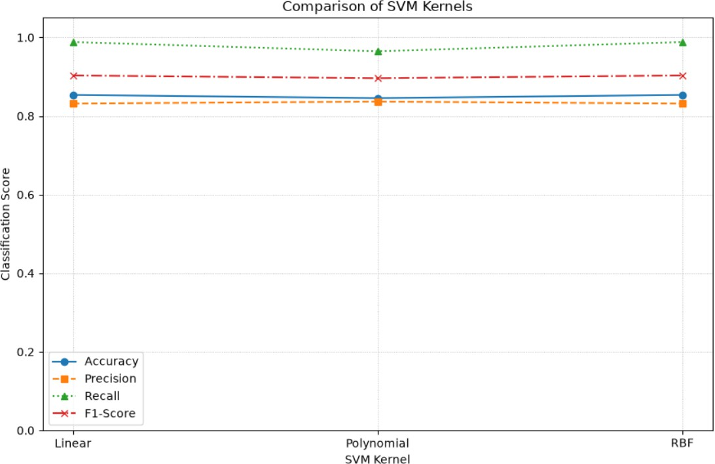
Figure 9.1. SVM kernel comparison on the test set.

Linear and RBF kernels give identical test results (about 85.4% accuracy), and the polynomial kernel is one percentage point lower. The difference between kernels corresponds to only one or two of the 123 test applicants, so it should not be over-interpreted. The similarity of linear and RBF suggests the classes are roughly linearly separable using the available features, chiefly credit history. All kernels favour the approved class (recall of 0.96 to 0.99 against 0.55 to 0.58 for rejections).

DECISION TREE AND RANDOM FOREST

Entropy-based ID3-style decision tree
The tree is a scikit-learn DecisionTreeClassifier with criterion = “entropy”, i.e. an ID3-style information-gain tree; it is not a strict textbook ID3 implementation (scikit-learn uses binary splits, handles numerical features and supports pruning controls). It was trained without depth limits.

Model | Accuracy | Precision (Y) | Recall (Y) | F1 (Y) | Recall (N)
Decision Tree (entropy) | 0.7480 | 0.8462 | 0.7765 | 0.8098 | 0.68
The unpruned tree has the lowest accuracy of all models (74.80%), which is typical of overfitting: it can memorise training data. It does, however, detect rejections best (recall 0.68; 26 of 38), at the cost of more missed approvals (19 of 85). Its confusion matrix is 26 true N, 12 false Y, 19 false N and 66 true Y (Figure 10.1).
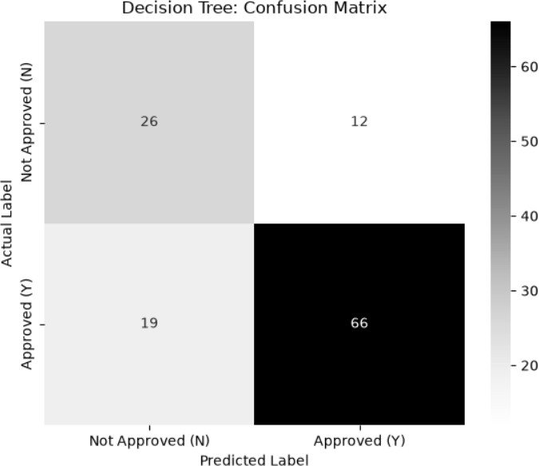
Figure 10.1. Decision tree (entropy): confusion matrix on the test set.

Random Forest tree-count comparison

Number of trees | Accuracy | Precision | Recall | F1-Score
1 | 0.6585 | 0.7471 | 0.7647 | 0.7558
5 | 0.7317 | 0.8023 | 0.8118 | 0.8070
10 | 0.7480 | 0.8140 | 0.8235 | 0.8187
20 | 0.7805 | 0.8372 | 0.8471 | 0.8421
50 | 0.7886 | 0.8242 | 0.8824 | 0.8523
100 | 0.8211 | 0.8462 | 0.9059 | 0.8750
250 | 0.8211 | 0.8387 | 0.9176 | 0.8764
500 | 0.8293 | 0.8404 | 0.9294 | 0.8827
1000 | 0.8211 | 0.8387 | 0.9176 | 0.8764

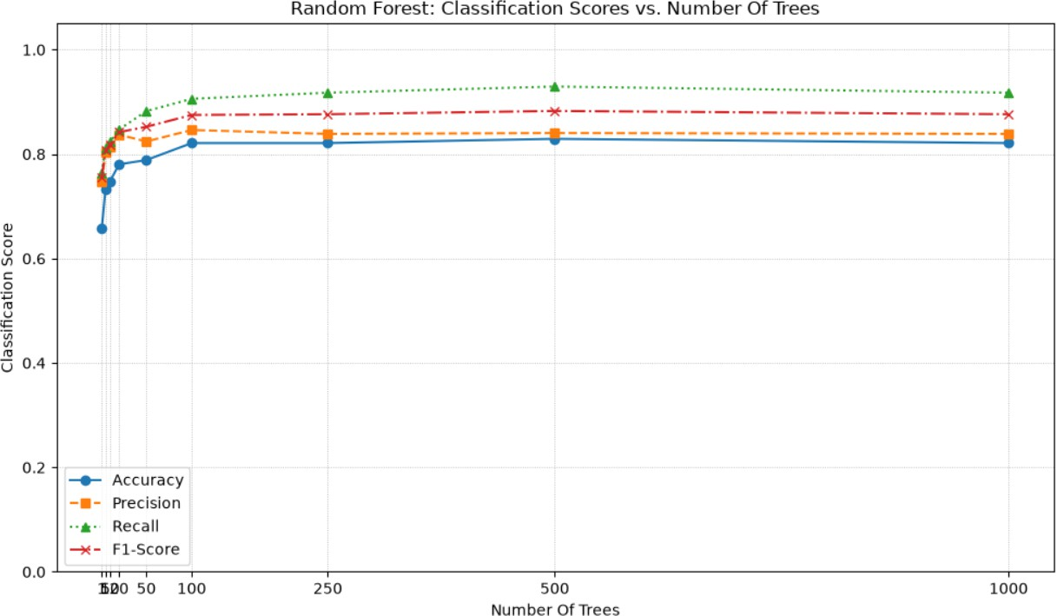
Figure 10.2. Random Forest scores versus number of trees.

A single tree scores 65.85% accuracy, below the decision tree above because the forest uses bootstrap sampling and random feature subsets with a small ensemble. Accuracy increases steadily up to about 100 trees (82.11%), peaks at 500 trees (82.93%) and then settles back to 82.11% at 1000 trees. Gains beyond 100 trees are within one or two test applicants, so the curve is effectively flat from 100 trees onward; more trees reduce variance but cannot fix bias or the limited information in the features. Random Forest improved on the single decision tree by about 7 to 8 percentage points but did not beat KNN or SVM on this split.

K-MEANS CLUSTERING
K-Means was applied to ApplicantIncome, CoapplicantIncome and LoanAmount after median imputation and standardisation, with k = 2, 3 and 4 (random_state = 42, n_init = 10). Loan_Status was not used. The clusters below are purely statistical groupings of financial figures; they are not credit grades and carry no judgement about the applicants.

k | Inertia | Silhouette score
2 | 1273.79 | 0.7332
3 | 920.69 | 0.7416
4 | 707.87 | 0.4592
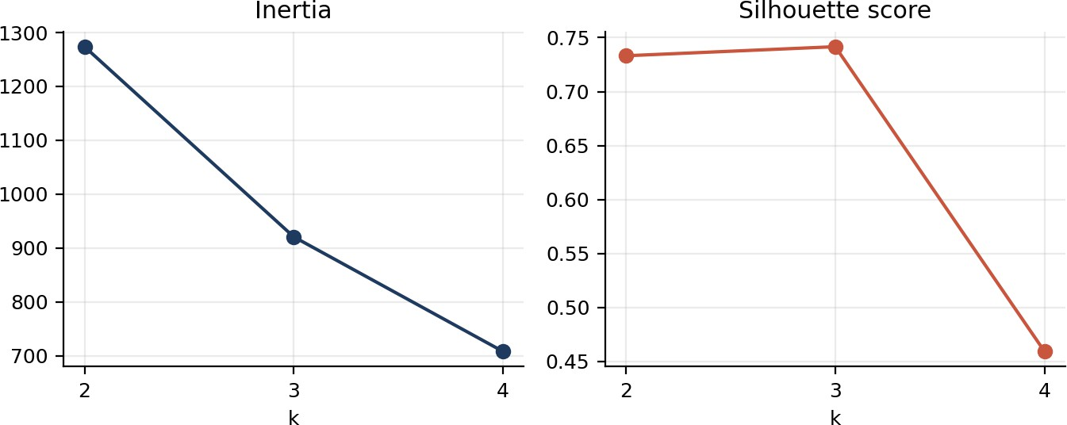

Figure 11.1. K-Means inertia and silhouette score for k = 2, 3 and 4.

Inertia always falls as k increases, so it cannot select k alone. The silhouette score is highest at k = 3 (0.7416), almost equal to k = 2 (0.7332) and much lower at k = 4 (0.4592). The high silhouette values partly reflect a handful of extreme records: with heavily skewed incomes, a few very large values form their own tight groups while most applicants stay in one large group.

k | Cluster | Mean applicant income | Mean co-applicant income | Mean loan amount | Neutral description
2 | 0 | 19642.72 | 4931.25 | 385.44 | Higher incomes, larger loans
2 | 1 | 4516.58 | 1415.09 | 130.94 | Lower incomes, smaller loans
3 | 0 | 4545.97 | 1401.83 | 132.65 | Modest incomes, smaller loans
3 | 1 | 23771.96 | 2288.32 | 414.57 | Very high applicant income, largest loans
3 | 2 | 1588.00 | 28876.00 | 195.50 | Very high co-applicant income, low applicant income
4 | 0 | 3877.55 | 1208.57 | 112.75 | Lowest incomes and loans
4 | 1 | 1588.00 | 28876.00 | 195.50 | Very high co-applicant income (as k = 3)
4 | 2 | 34956.64 | 1191.64 | 452.29 | Highest applicant income and loans
4 | 3 | 7965.21 | 2352.16 | 232.47 | Mid-range incomes and loans
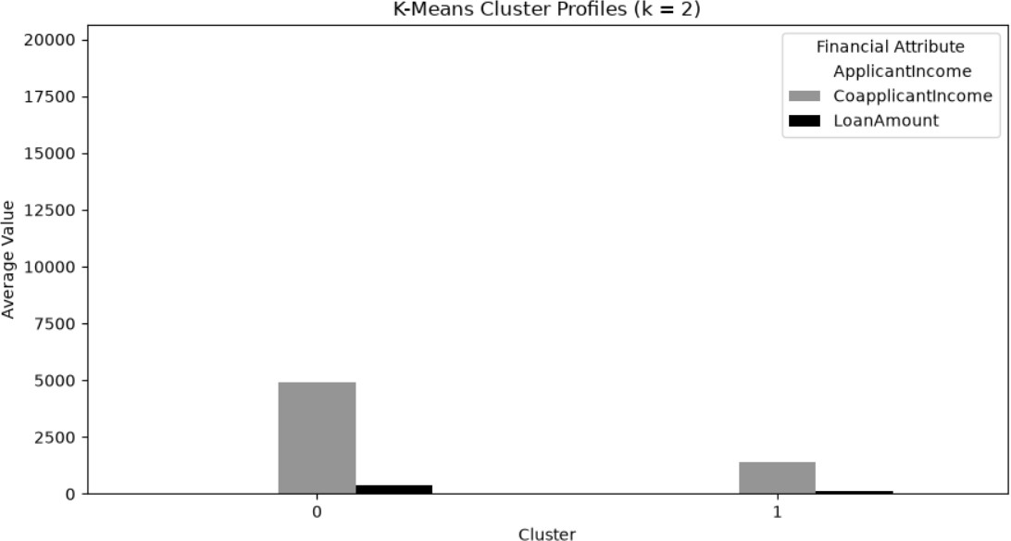
Figure 11.2. K-Means cluster profiles (k = 2).
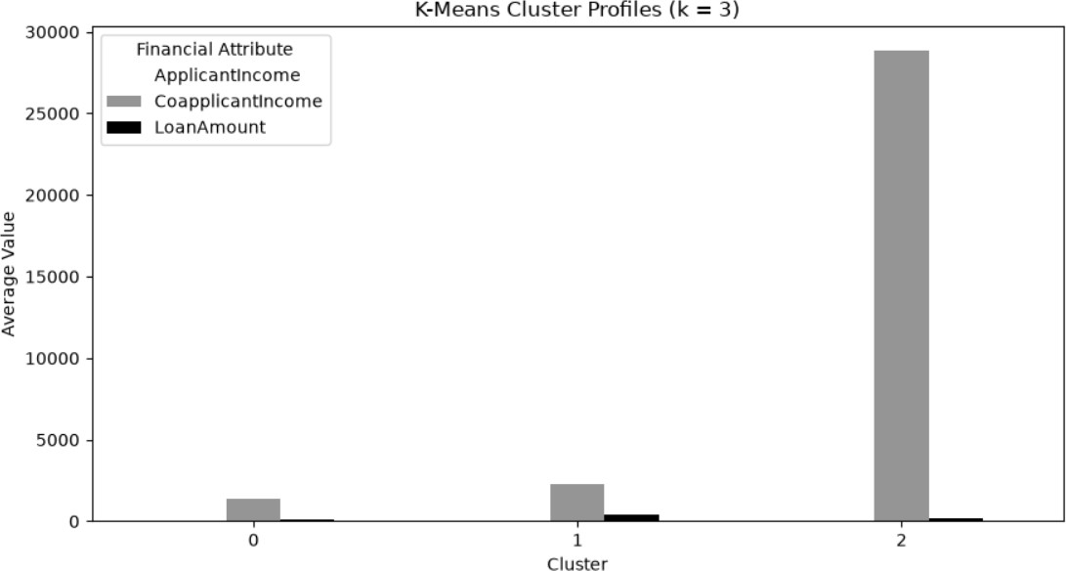
Figure 11.3. K-Means cluster profiles (k = 3).

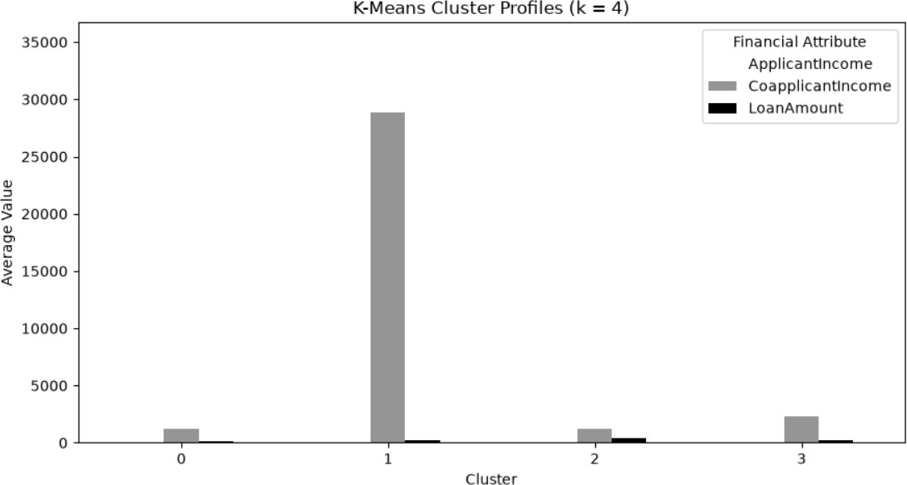
Figure 11.4. K-Means cluster profiles (k = 4).

Moving from k = 2 to k = 4 separates the dominant group of ordinary applicants into lower and mid-range segments and isolates two unusual groups: very high applicant income with very large loans, and very high co-applicant income. Cluster sizes were not printed in the notebook; the identical means of the co-applicant-income cluster for k = 3 and k = 4 (1588.00 / 28876.00 / 195.50) suggest it contains very few applicants, so it is driven by outliers. Log scaling or outlier handling would give more balanced segments.

OVERALL MODEL COMPARISON
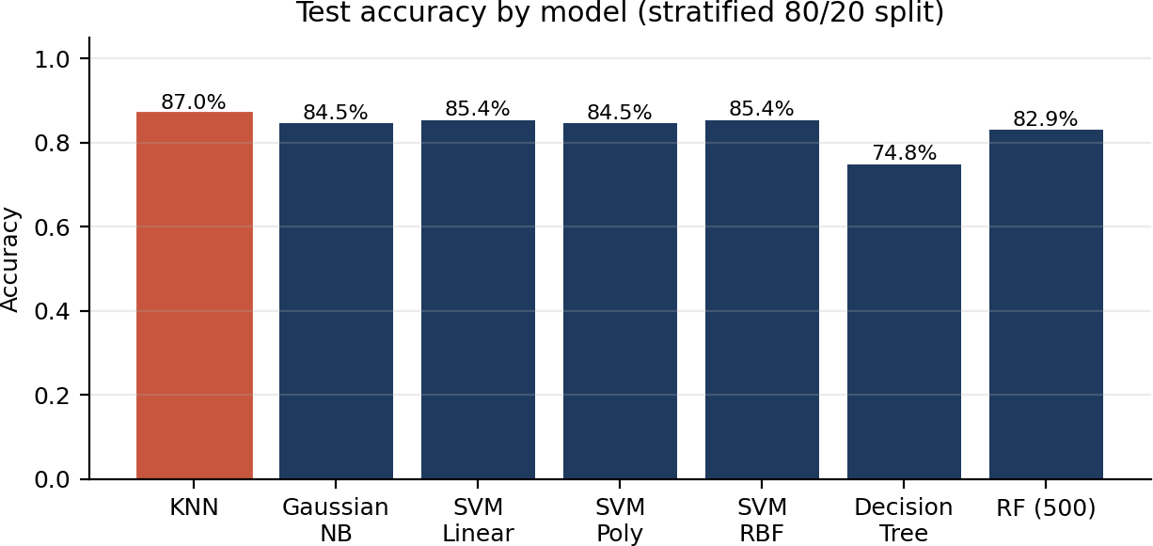
Figure 12.1a. Test accuracy of all classifiers (Random Forest shown at its best tested size, 500 trees).

Model | Accuracy | Precision (Y) | Recall (Y) | F1 (Y) | Recall (N)
KNN (k=5) | 0.8699 | 0.8485 | 0.9882 | 0.9130 | 0.61
Gaussian Naive Bayes | 0.8455 | 0.8367 | 0.9647 | 0.8962 | 0.58
SVM Linear | 0.8537 | 0.8317 | 0.9882 | 0.9032 | 0.55
SVM Polynomial | 0.8455 | 0.8367 | 0.9647 | 0.8962 | 0.58
SVM RBF | 0.8537 | 0.8317 | 0.9882 | 0.9032 | 0.55
Decision Tree (entropy) | 0.7480 | 0.8462 | 0.7765 | 0.8098 | 0.68
Random Forest (500 trees) | 0.8293 | 0.8404 | 0.9294 | 0.8827 | n/a

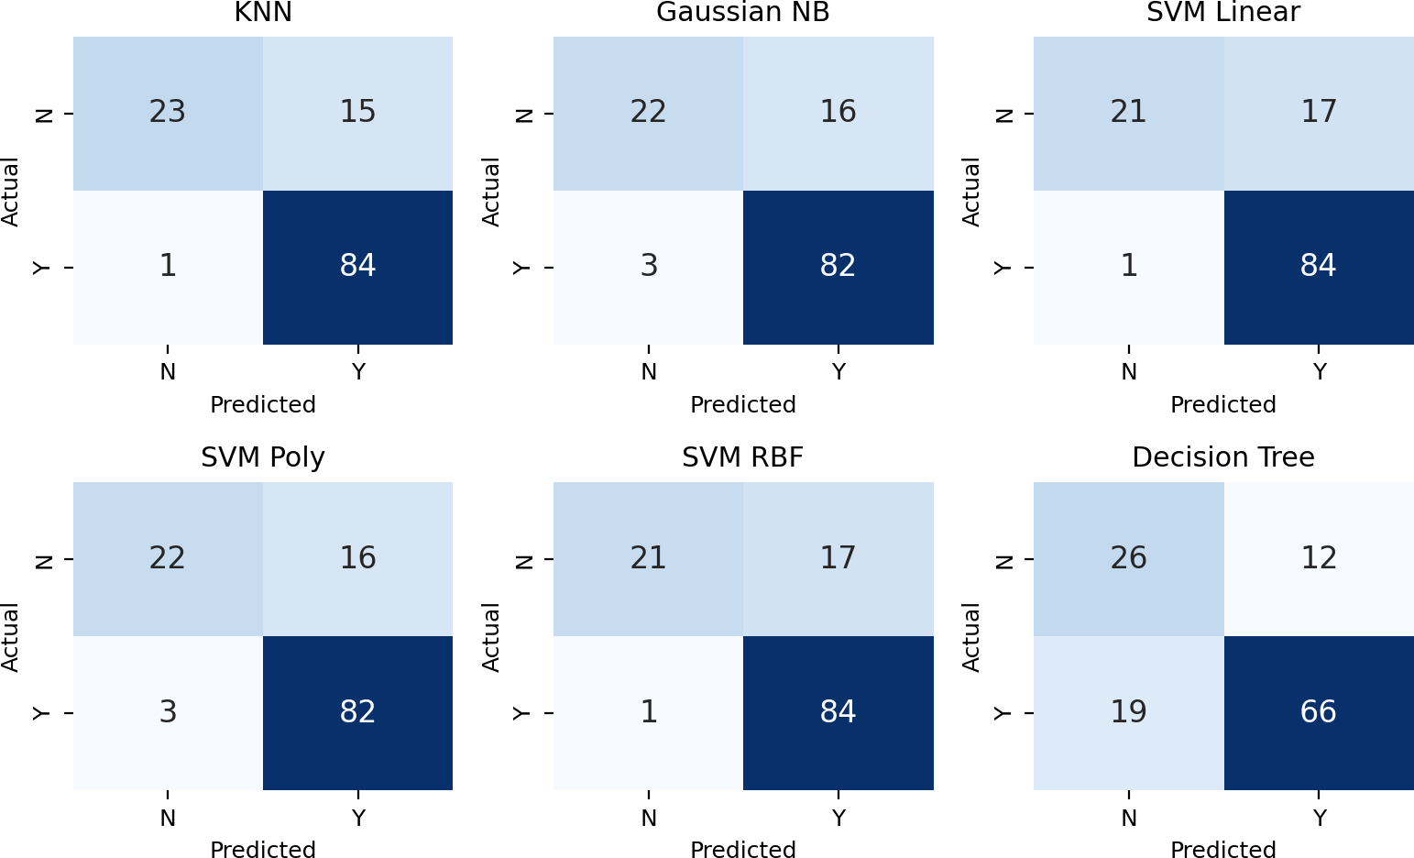
Figure 12.1. Confusion matrices on the test set (N = Not Approved, Y = Approved). The decision-tree matrix is read from the notebook; the others are reconstructed exactly from the reported class recalls, supports and accuracies.

KNN is the strongest model on this split (86.99% accuracy, F1 0.913), followed by linear and RBF SVM. However, the test set contains only 123 applicants, so one prediction changes accuracy by 0.8 percentage points and the ranking among the top four models is not statistically reliable. Every model except the decision tree has high recall for approvals (0.96 to 0.99) but misses 39% to 45% of historical rejections, so high accuracy partly reflects the 69/31 class imbalance. Repeated stratified cross-validation and class-weighting would give more dependable comparisons.

FAIRNESS, PRIVACY AND CLASS IMBALANCE
Fairness. The feature set contains Gender, Married, Dependents, Education and Property_Area. Some are protected characteristics in many jurisdictions, and others can act as proxies for them. The data are skewed (Gender: 489 male against 112 female records), so group-level error rates may differ even if overall accuracy looks good; the notebook does not measure group fairness. A real system would need to exclude or audit these attributes, compare approval and error rates across groups and review the label itself for historical bias.
Privacy. Loan, income and credit data are sensitive personal financial information. Real use would require lawful consent, minimisation, anonymisation, secure storage and clear retention limits. Here, Loan_ID is dropped before modelling and no personal identifiers are reported.
Class imbalance. With 68.73% approvals, accuracy alone is misleading. The classifiers favour the majority class and recall for rejections is only 0.55 to 0.68. Possible remedies are class weights, resampling, threshold tuning and reporting per-class metrics.

Why this must not be an automatic approval system.
- The labels are past decisions, not proof of repayment behaviour, so the model would copy historical bias.
- The dataset is small, from one source, and the test set has only 123 rows, so the results are statistically fragile.
- Missing values (including 8% of credit histories) were filled with simple statistics, which hides uncertainty about real applicants.

- The models give no calibrated confidence, explanations or appeal route, which lending rules and good practice require.
- Errors have real consequences: a false rejection denies a person credit, and a false approval creates financial risk. Decisions must stay with accountable humans.

DISCUSSION, LIMITATIONS AND CONCLUSION

Limitations
    - One stratified split and fixed hyper-parameters were used; cross-validation, confidence intervals and systematic tuning were not performed.
    - Regression explains little variance (R2 = 0.09) and loan amount is skewed with extreme values; transformations were not tried.
    - K-Means is sensitive to outliers and skewed income; cluster sizes and stability across seeds were not examined.
    - No fairness metrics were computed; the dataset limits and the unit of the monetary fields come from the source and are not independently verified.
    - The tree is ID3-style (scikit-learn, entropy criterion), not strict ID3.

Conclusion
The project completed the full supervised and unsupervised workflow on the loan-approval data using leakage-safe pipelines. Linear Regression explained little of the loan amount (R2 = 0.090, MAE 36.61, RMSE 57.91). Among classifiers, KNN (k = 5) achieved the best accuracy (86.99%) and F1-score (0.913), linear and RBF SVM reached 85.37%, Gaussian Naive Bayes and the polynomial SVM 84.55%, Random Forest improved from 65.85% (1 tree) to 82.93% (500 trees), and the entropy decision tree was weakest at 74.80%. K-Means produced descriptive financial segments dominated by a few extreme-income groups. The strongest lesson is that models mainly reproduce the majority class and the historical pattern: they are useful for study, not for deciding whether a real person receives a loan.

REFERENCES
- Loan Prediction (loan-approval) public dataset, datasets/data.csv. [Insert source URL and access date.]
- Pedregosa, F. et al. (2011). Scikit-learn: Machine Learning in Python. Journal of Machine Learning Research, 12, 2825–2830.
- Scikit-learn documentation: Pipeline, ColumnTransformer, SimpleImputer, StandardScaler, OneHotEncoder, LinearRegression, KNeighborsClassifier, GaussianNB, SVC, DecisionTreeClassifier, RandomForestClassifier, KMeans, silhouette_score.
- Machine Learning Lab (CSUP521), Mini Project Assignment Set 06: Loan Approval Prediction and Applicant Segmentation, SKIT Jaipur.

